**Lec 23: Neural Network Overview**

Here we are representing logistic regression in each of the two layers:

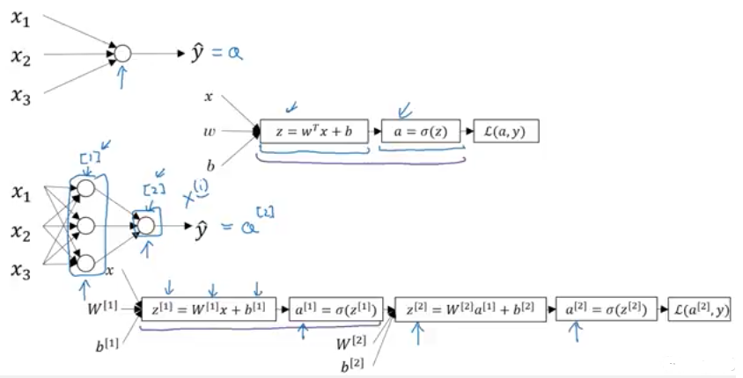

Backpropagation for derivative calculation is also computed in similar way.

**Lec 24: Neural Network Representation**

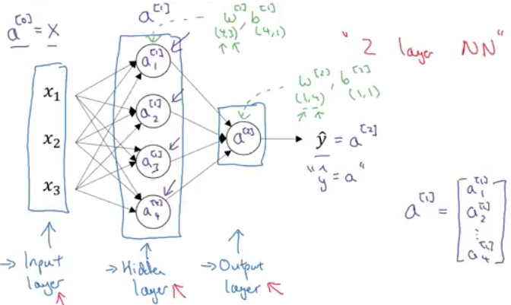

**Lec 25: Computing a Neural Network’s Output**

Each neuron in the hidden layer computes logistic regression, first it find (z) then (a):

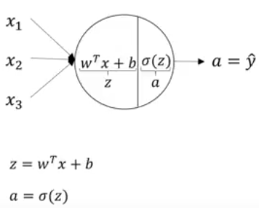

Below is the formulation for logistic regression of the first two nodes of the first layer (hidden layer):

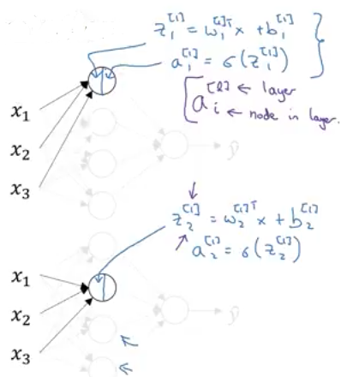

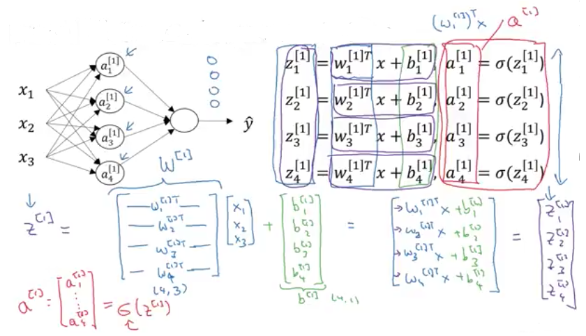

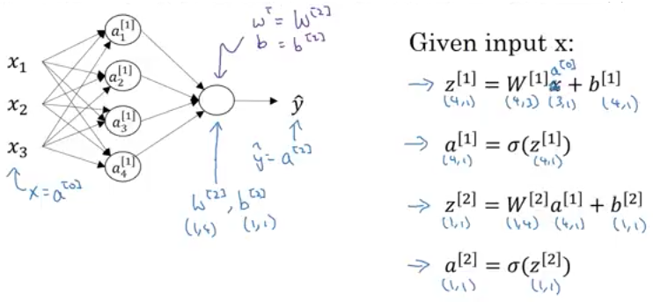

**Lec 26: Vectorizing Across Multiple Training Examples**

The ‘for’ loop implementation across all ‘m’ training examples:

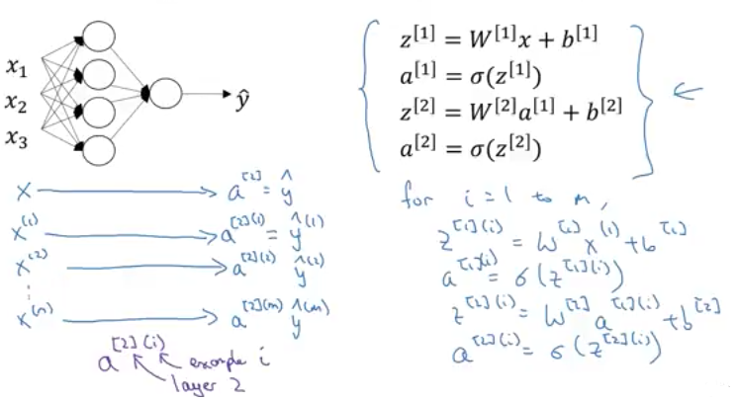

Replacing the ‘for’ loop implementation by vectorizing:

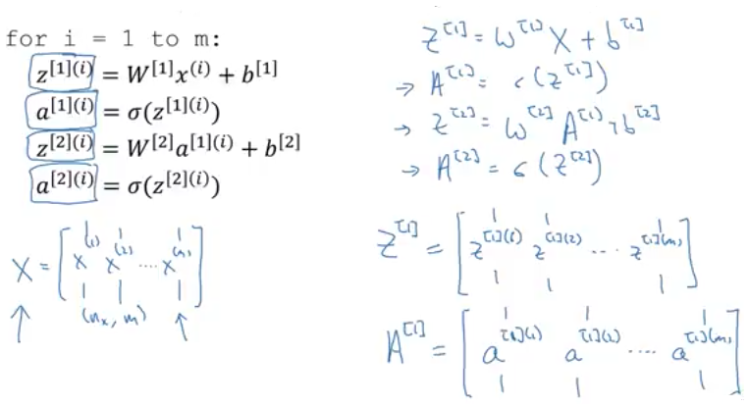

*Point to note:*

In the matrix ‘A’ and ‘Z’, the top left element corresponds to the activation result of the first training example of the first hidden layer.

Likewise, horizontally across we move from one to the next training example. Vertically downwards we move from one activation neuron of one layer to next neuron of the next layer.

**Lec 27: Vectorized Implementation Explanation**

Justification of vectorization:

